Contents
1 Introduction 3
1.1 Purpose and Scope 3
2 Design Overview 3
3 Detailed Design 5
3.1 Production Code 5
3.1.1 Class CDiscoverer 5
3.1.2 Class CRegistrar 5
3.1.3 Class CRegistryData 5
3.2 Test Code 6
3.2.1 ECOM Regression Test Code 6
3.2.2 Unit Test Code 6
3.2.3 Component Test Code 6
4 Design Considerations 6
4.1 Selective update registry data 6
4.1.1 Solution discussion: 6
4.1.2 Summary 7
4.2 Unnecessary persistence during a language change 7
4.2.1 Solution discussion: 7
4.2.2 Summary 7
5 Further Information 8
5.1 References 8
5.2 Open Issues 8
5.3 Glossary 8
5.4 Document History 8

Introduction

Purpose and Scope
This document describes the changes required to the ECOM component in order to satisfy CR0902 “Enable Dynamic Language Switching in APPARC, ECOM and EIKSTD“. See [R1] for more CR information. This CR is required for 9.3.
The target audience of this document should be the TA and engineers within System Libraries, Tools and Test Engineering. Also the Project Manager responsible for the CR delivery.

Design Overview
This CR requires ECOM should be able to detect language switch during running time, and to rebuild registry data.
Currently ECOM detects language switch only on the start-up time. ECom can select correct localised resource entries based the language downgrade path with both SPI enable and SPI disable use cases.
- When SPI enable on read-only drives, ECOM is to be able to interpret multiple SPI files by using BAFL::RResourceArchive. By providing private data cage path \\private\\10009D8F\\, resolution of the resources inside the SPI files is done inside RResourceArchive. Resolving of the localised resource files is based on the language downgrade path.
- ECOM is also able to pick up correct resource file entries in directory \\resource\\plugins\\ in each drive by using Bafl::NearestLanguageFile directly.
According the current design, ECom can be modified to enable detect language switch in run time without changing whole structure. Firstly ECOM will get notifications when dynamic language switch happens. ECOM then will compare current language downgrade path with previous one stored in the ECom language file (ECom.lang). If they are different, ECOM will set a flag to indicate language change and the flag is used to force existing entries on all drives to be updated.
The changes outlined in this section are for the notification of language switch and routines of rebuild registry data. Specifically the functions are related to notification of language switch, indication of the change in language downgrade path, directory scan and plugin rediscovery on all drives. Those functions need to be updated to be able to detect dynamic language downgrade path changes, scan all drives and discover plugins.

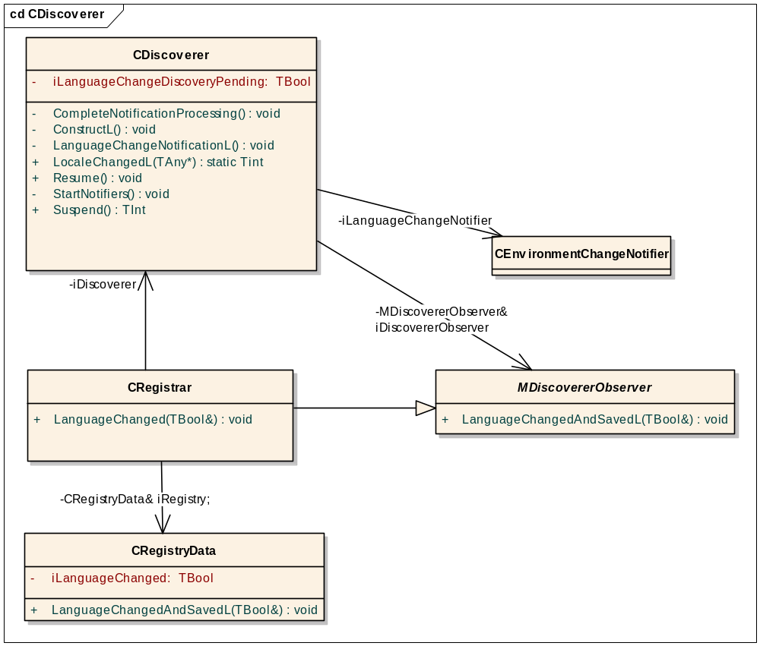
- Discoverer Design Diagram (It reflects only those data members or functions which are either new or modified)

Detailed Design

Production Code

Class CDiscoverer
- Add a data member iLanguageChangeNotifier of class CEnvironmentChangeNotifier to monitor system change events.
- Add a data member iLanguageChangeDiscoveryPending to indicate a discovery pending due to Language changes.
- Add a static call back function LocaleChangedL(). This has to be a static member function so that it can be encapsulated into a TCallback object for using with an object of CEnvironmentChangeNotifier. The call back function will take TAny pointer as parameter - by passing in a "this" pointer so that while remaining a static function it can access all the member data. The call back function will do following steps:
  - Use EChangesLocale to filter out the events other than language switch,
  - Call iDiscovererObserver::LanguageChangedL to check whether the language down path is really changed and set flag iLanguageChanged properly.
  - If the language down path has been changed, set iLanguageChangeDiscoveryPending to be true, and call the function CDiscoverer:: LanguageChangeNotificationL to rebuild registry data.
- Add a member function LanguageChangeNotificationL(). If there is no discovery pending, the function ProcessDNEventL() will be called for scanning each drive available in the system.
- Modify existing ConstructL() to initialize iLanguageChangeNotifier by passing call back function LocaleChangedL
- Modify existing StartDNNotifier() to call start() for activating the iLanguageChangeNotifier. The class CEnvironmentChangeNotifier has taken care of the case which makes sure it won’t invoke the callback function when it calls CEnvironmentChangeNotifier ::start() at first time. Also it has filled out those non system events (like copy and delete activities).
- Modify existing Resume() to activate the iLanguageChangeNotifier.
- Modify existing Suspend() to Cancel the iLanguageChangeNotifier
- Modify existing CompleteNotificationProcessing() to set flag iLanguageChangeDiscoveryPending false.
- Add a new virtual function void LanguageChangedL(TBool& aLanguageChanged) in DiscovererObserver.h file.

Class CRegistrar
- Add new function void LanguageChangedL(TBool& aLanguageChanged). In turn the function will call CRegistryData:: LanguageChangedL().

Class CRegistryData
- Add new function void LanguageChangedL(TBool& aLanguageChanged) to check whether the language down path has been changed. If it has been, set the flag to indicate the language down path has been changed and persist current information in ECOM language file.
- Modify existing ConstructL() by moving the part for checking and saving language down path to the new function LanguageChangedAndSavedL().

Test Code
Regression tests for ECOM server Discovery functionality need to be updated. New unit tests for scanning all drives due to language changes will be added.
New component tests for dynamic language switch will be required.
Existing Performance tests will be re-run and expected result should be passed. Also comparison performance tests before and after CR will be done privately in order to check whether the CR will affect ECOM performance.

ECOM Regression Test Code
Tests that directly link Discover routines have to be updated due to production code change.

Unit Test Code
The following new unit tests are required due to changes of discovery routines:
- Add unit tests for new function LanguageChangeL() in t_discovery to make sure each drive in the system has been scanned.
- Add unit tests for new function LanguageChangedL() in t_registrydata to make sure the flag iLanguageChanged set properly when language downgrade change happens.

Component Test Code
Currently test suit T_language has existing test cases to test language downgrade path change in start-up time. For each corresponding test case, a new test case will be added to test same scenario in run time.
Since existing t_language is focus on creating different sets of language dependant resource file on C: drive and verify the ECom discovery process, new component tests will be added for creating different sets of language dependant resource file on Z: drive so that use cases with SPI on will be tested tool.
- Create a plugin with different localised resource files e.g x.RSC, x.R01, x.R02 etc
- Put those files on Z: drive.
- Write test code to change the locale and check the correct resource entry has been discovered.
- The new test suit will be run manually on hardware For SPI off case.

Design Considerations

Selective update registry data
ECOM might be optimised in the way the registry data is rebuilt at time of dynamic language switch happens. Only the affected resource file entries in the registry data will be re-built, not the whole registry data.

Solution discussion:
The option is based on assumption there is no new plugin during language switch so ECOM just needs to update existing registry data. The assumption is valid since ECOM has already taken care of the part related new plugin rediscovery (see ECOM design document)
Since ECOM has created a DLL list in each drive already which was created and updated during ECOM starts up. For each element in a DLL list on non read-only drive, it has fields which contain resource file name and extension name and they can be reused in the option design.
With SPI enable, ECOM will do the same things as option 1 by Using Bafl:: RResourceArchive to pick up correct SPI file entries. The part also can be optimised by modifying BAFL and RResourceArchive, but it needs further investigation.
However, with SPI disable, ECOM will look at the DLL list in each drive. For each DLL in the DLL list, it has a DLL name and resource extension. By passing the information to BAFL:: NearestLanguageFile, ECOM will get correct resource file extension after language switch. After comparing these two extension names, ECOM can decided whether the resource file need to be opened and read in order to construct a new DLL entry to replace with old DLL entry.
This design involves a quite few changes in registry and discovery routines. For example, ECOM need to be updated to add file extension field in non-SPI drive. New functions for updating DLL list in each drives are required in discovery and registry routines.
Pros: Good performance for non SPI drives. Resource files don’t need to be opened and read until it necessary.
Cons: Complex code change.

Summary
The current design requires less code change but it is not very optimal in all cases. The option in section 4.1 would result in better ECOM performance in non SPI drives. However, it will cause additional complexity. Further more, At this point most of use cases are SPI enable and there is no real driver to optimize, plus acceptance of the downgrade performance that would be seen by a user for current design, the option in section 4.1 is not selected to address this CR.

Unnecessary persistence during a language change
For a language change all exisitng DLL's on the device are marked for update. CRegistryData::UpdateDllDataL() removes the dll entry and then calls CRegistryData::AddDllDataL(). iRegistryChanged is set to true. So for a language change all dat files are unnecessarily persisted.

Solution discussion:
Enable building of resource file extensions for RO internal drives but for non SPI only and Modify CRegistryData ::IsRegisteredWithDate () by comparing file extension. Then only update if the RSC extensions are different and if the existing extension has a length greater than 0 (this accounts for ext not set for SPI case).
Pros: If the registry remains unchanged then dat files are not persisted during a language change.
Cons: The solution will cause a degradation to boot time and offset any saving during rescan.
.

Summary
For a language change DAT files both on C: and Z: will be regenerated even thought the their content may be the same. For non SPI only we can modify CRegistryData::IsRegisteredWithDate () by comparing file extension. However, It will cause a degradation to boot time and offset any saving during rescan.

Further Information

References
No. | Document Reference | Version | Description
[R1] | SGL.TS0017.648 IA Report CR0902 .doc | V1.0 | Overview of the work needed to implement CR 0902, “Enable Dynamic Language Switching in APPARC, ECOM and EIKSTD”.

Open Issues

Glossary
Term | Definition
CR | Change Request
Language Downgrade Path | An array of up to eight TLanguage values. The first one is the language of the current locale.

Document History
Date | Version | Status | Author | Description
2006-10-13 | 0.0 | Draft | Pauline | First draft
2006-10-18 | 0.1 | For review | Pauline | Update document according to review comments.
2006-10-19 | 0.2 | For review | Pauline | Update document according to the second review comments.
2006-11-09 | 1.0 | Issue | Pauline | Issue
2007-01012 | 1.1 | For Review | Pauline Pan | Update for DEF098984
2007-01019 | 1.2 | Issue | Pauline Pan | Issue

